1. Start - Apache , MySql
2. In mysql - admin

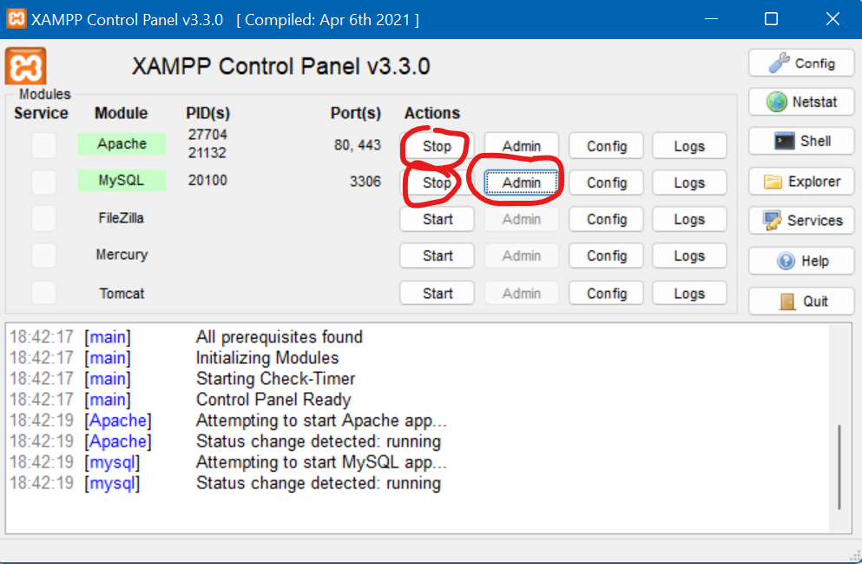

1. See the path that is first you should click new and then enter database as youtube and then enter table name as register.

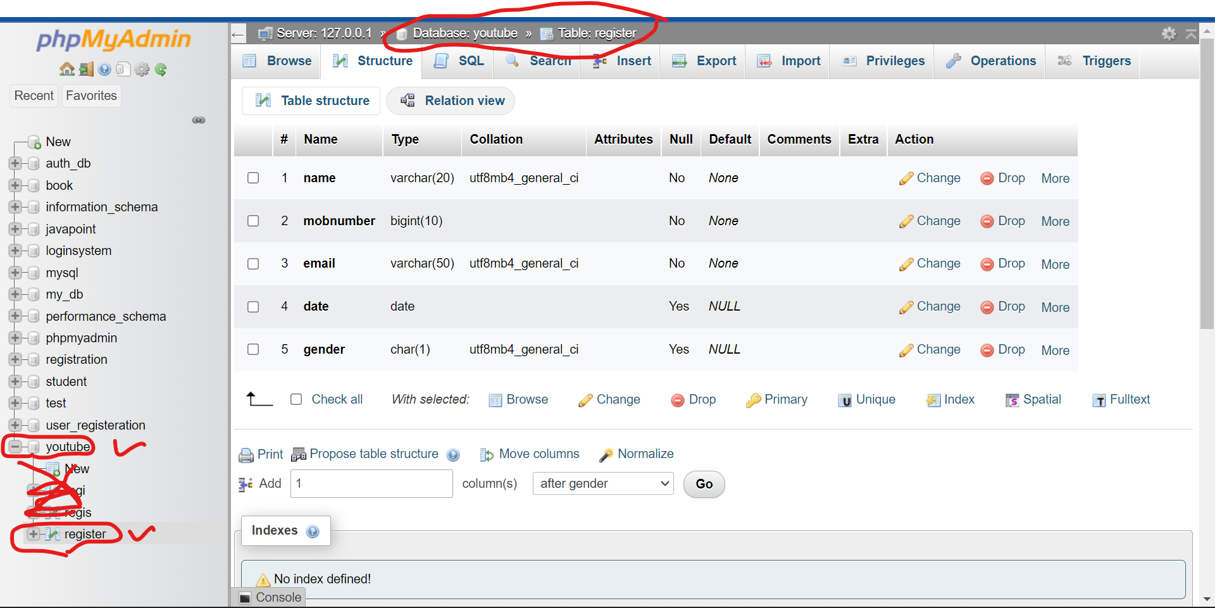

1. After entering in the form it will be store in the database.

